12/11/2023

Esirigho

Active Directory on Windows Server

**Assignment #3:**

Here is an overview of functionality of the Windows Active Directory (AD). Active Directory helps organize all users, computers, other network resources and their associated accesses including permissions. This aids in resource allocation management and maintenance. AD is essential for maintaining the security posture of an organization. The access to network resources is managed through security policies. Simply put an Active Directory is a centralized database that stores and manages information about all the resources within the organization.

Advantages:

* Centralized resources and security administration.
* Single logon for access to global resources.
* Simplified resources and security.

Disadvantages:

* It only runs in Windows environments.
* Because AD manages the network, the entire network will go down if AD fails.
* Setup and maintenance costs can be high.
* Legacy AD is limited because it requires on-prem infrastructure.

**How to create an Active Directory on your Virtual Machine**

1. Log into your vmware ESXi Host Client system:

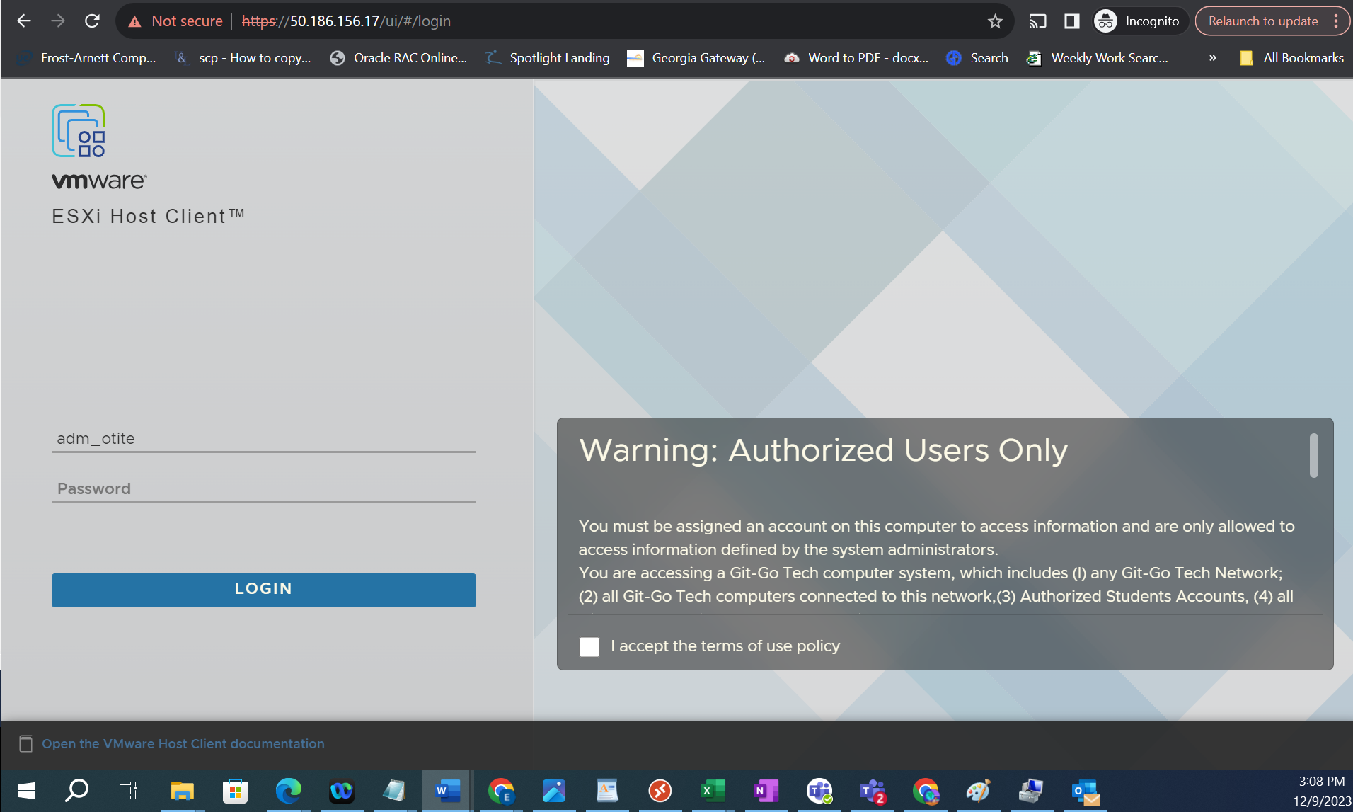

1. Find your box highlight it and log into your box:

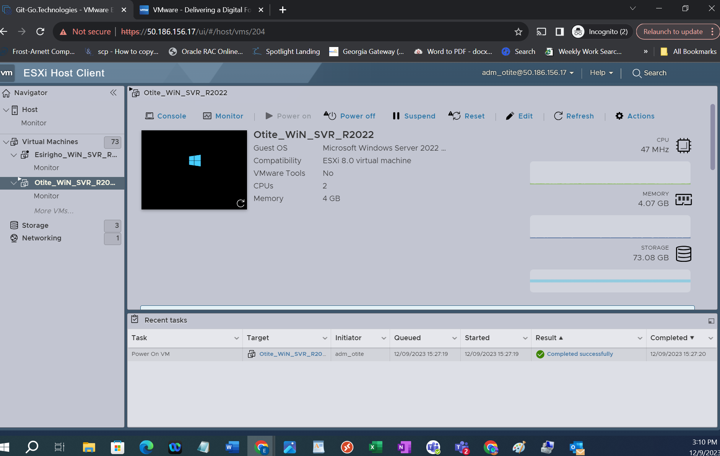

1. Select console (Open on a new window). Enter you password:

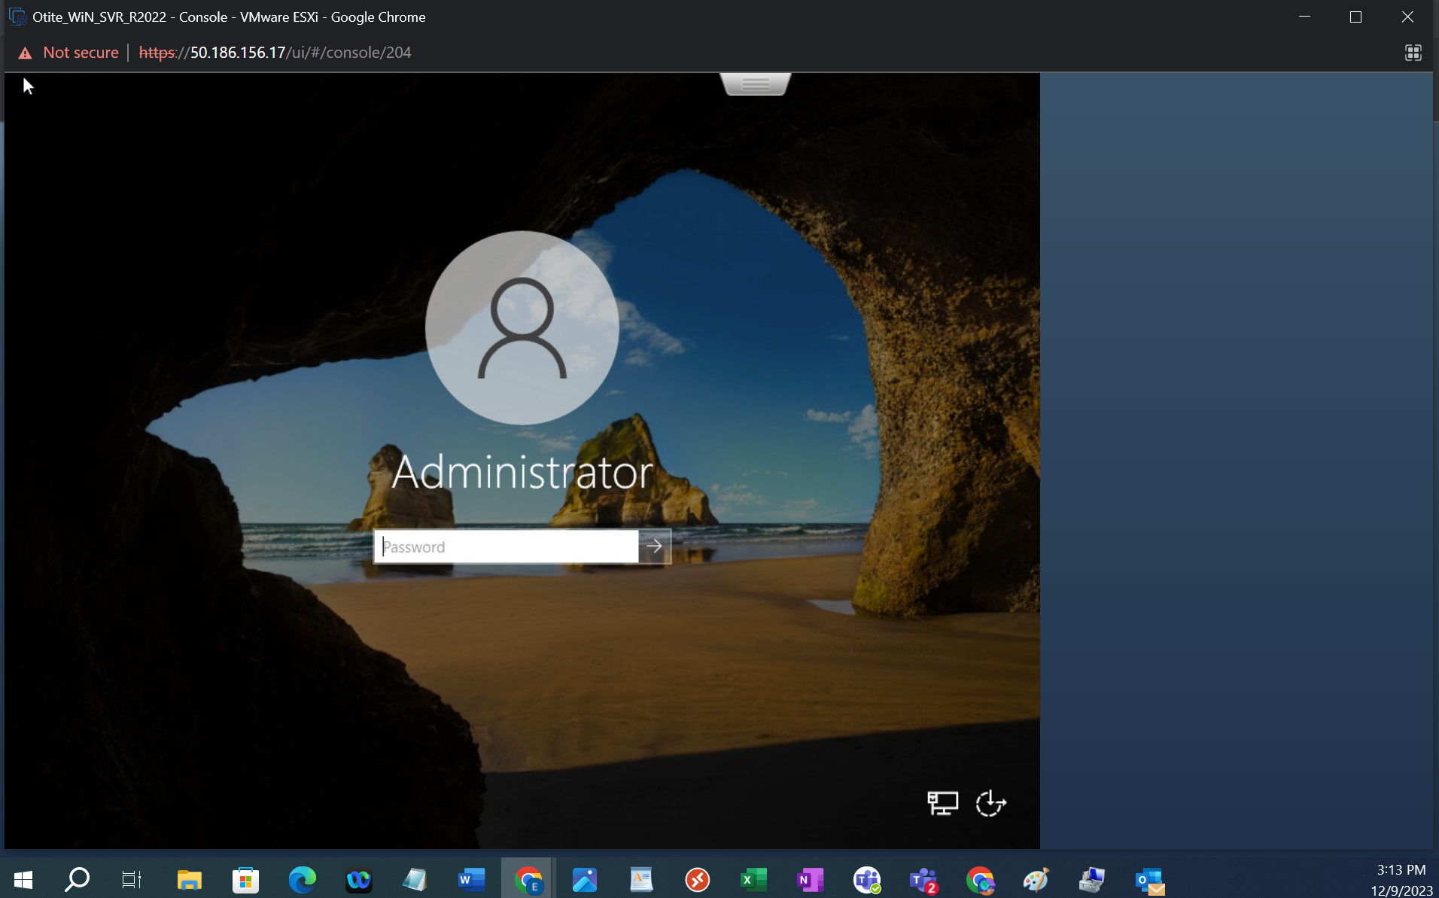

1. Once you are in your box, do a search in the windows search box for “Server manager”:

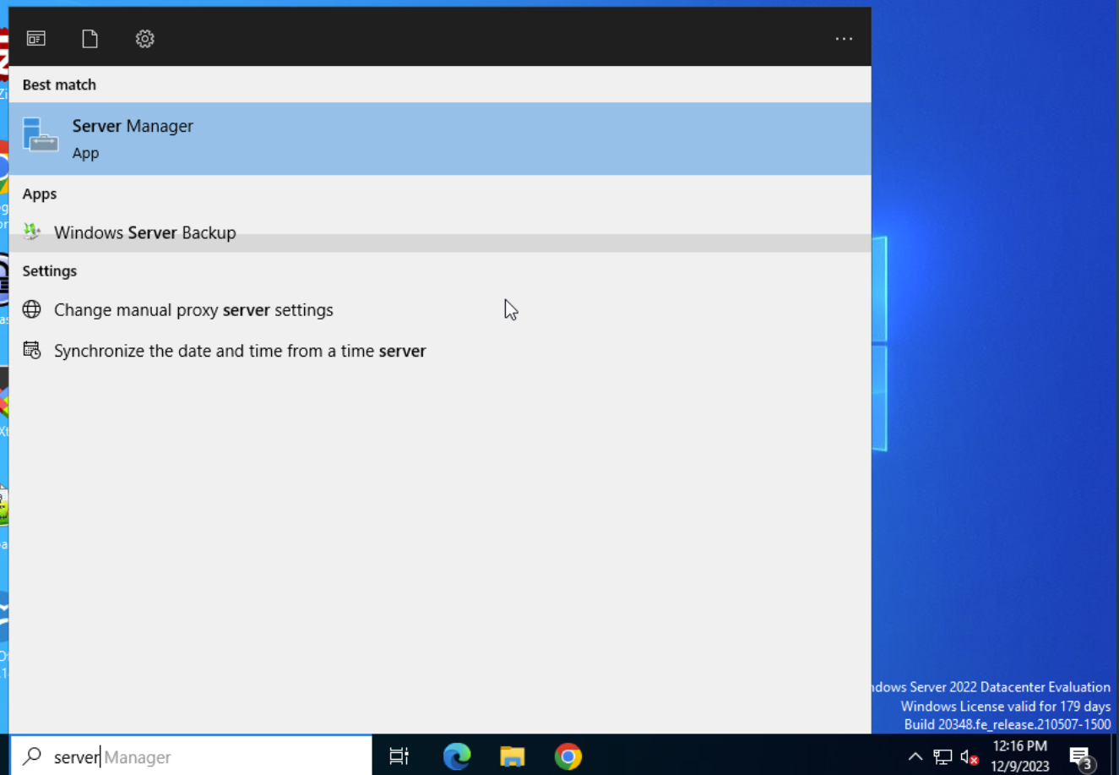

1. Select Manage on the tool bar 🡪 Then select Add Role and features:

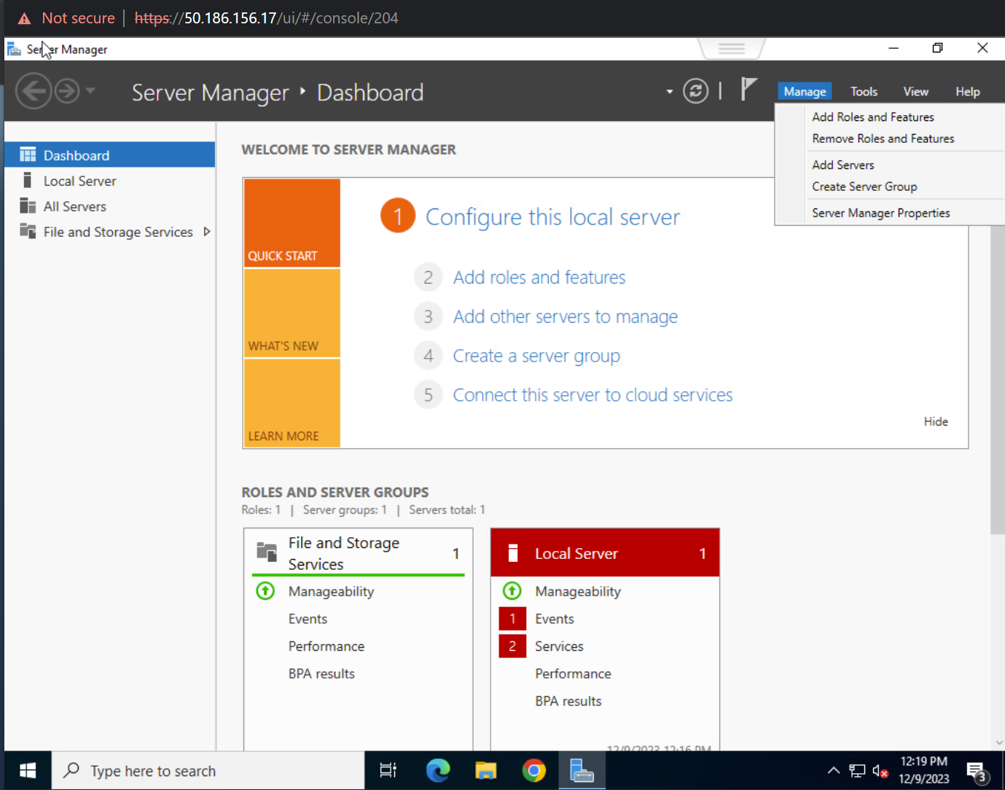

1. A wizard window will guide you through the setup:

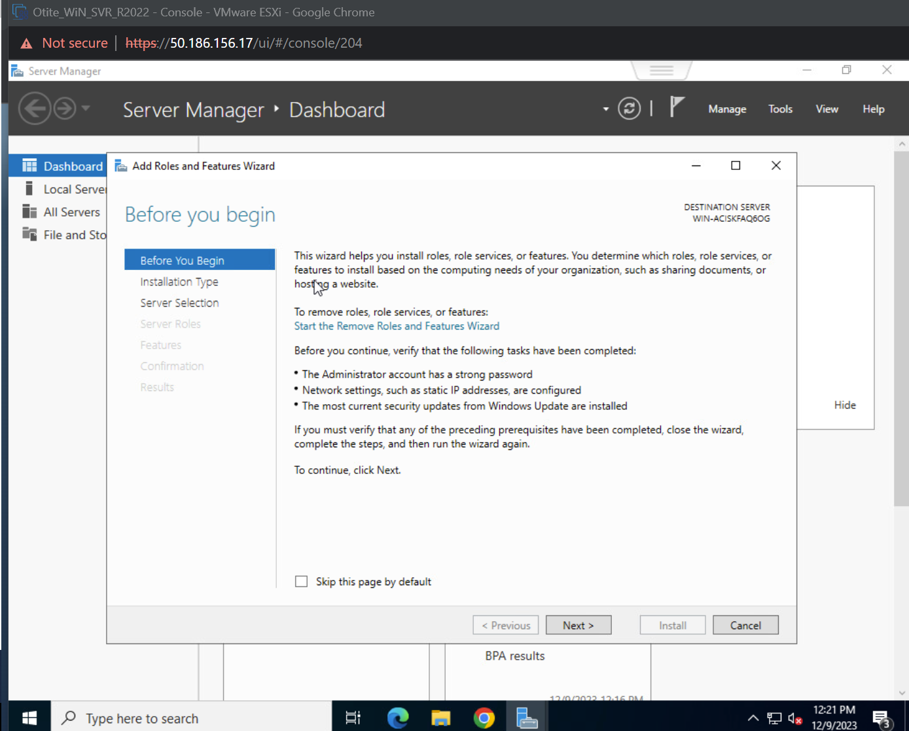

1. Select “Role-based or Feature-based installation”:

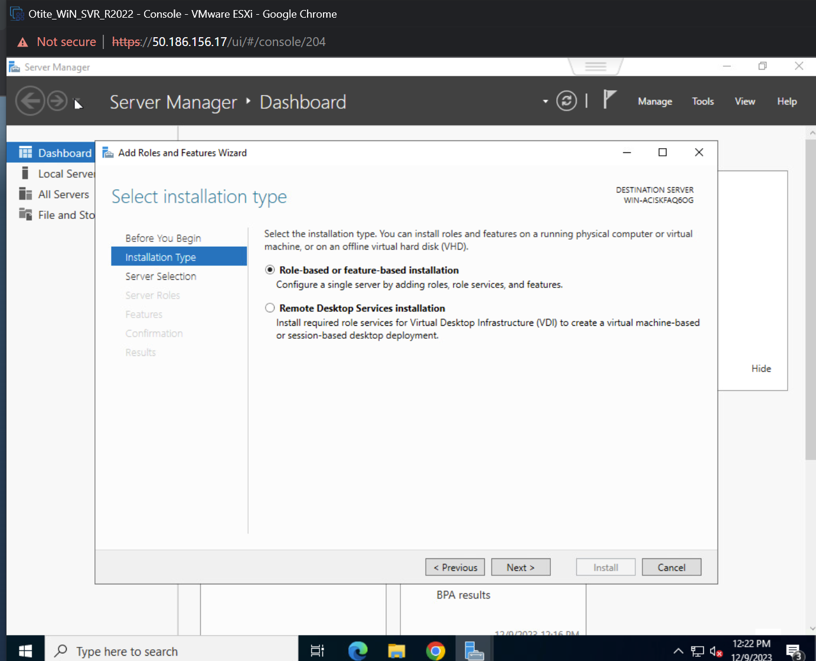

1. Server Selection:

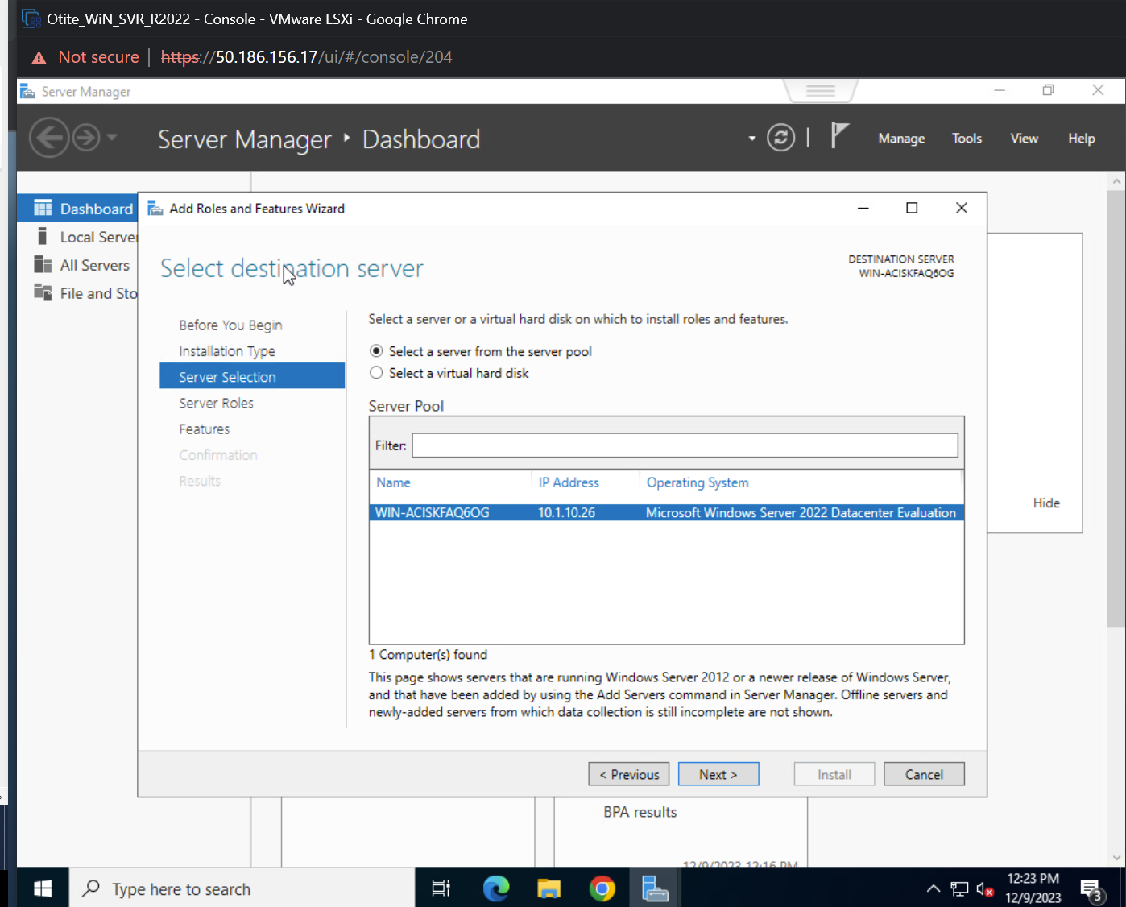

1. Under Server Roles: Select “Active Directory Domain Server”:

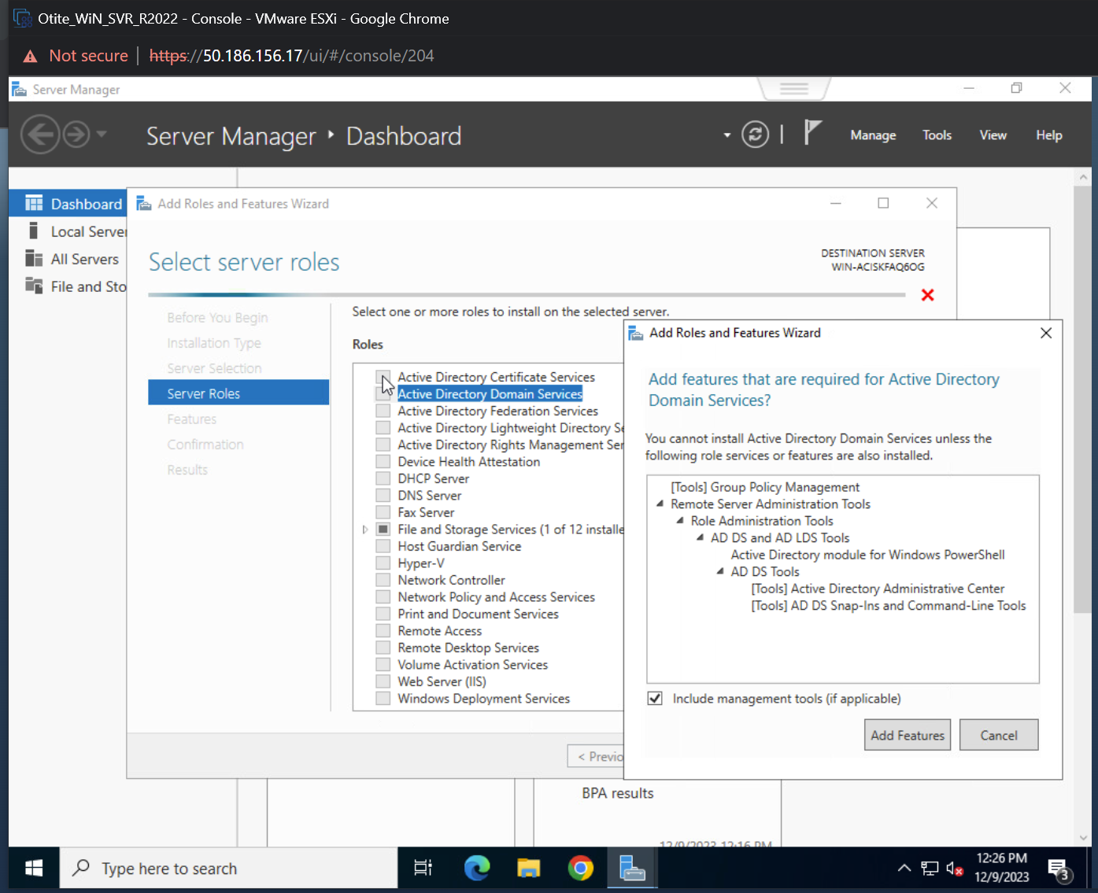

1. File and storage service:

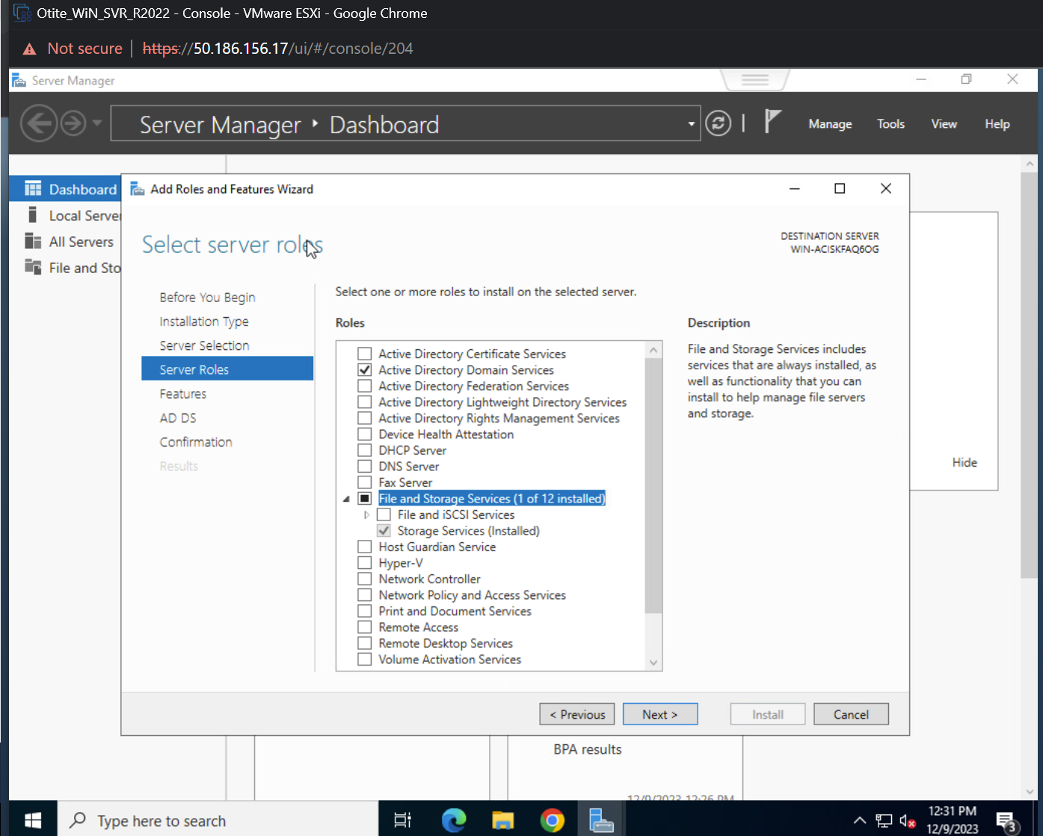

1. Features:

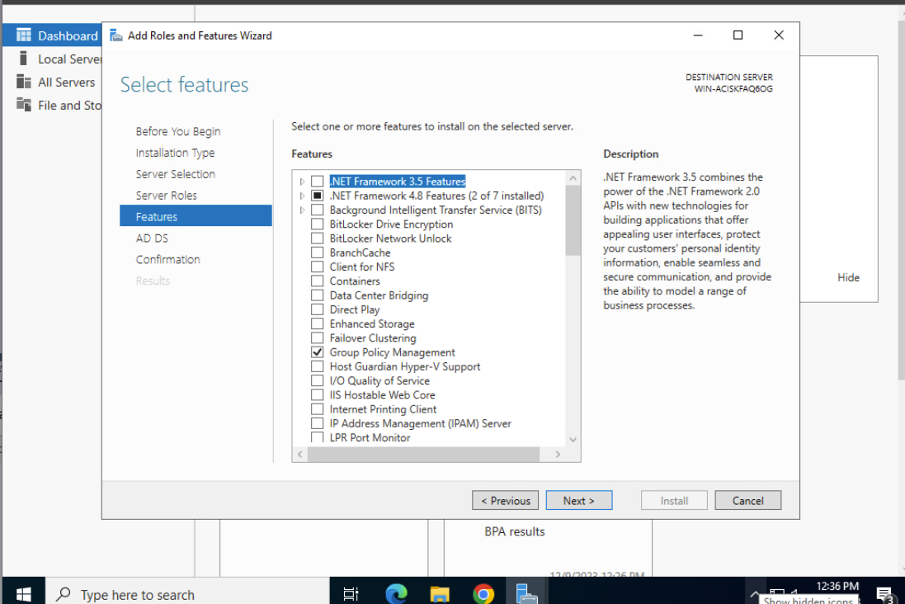

1. Next under AD DS:

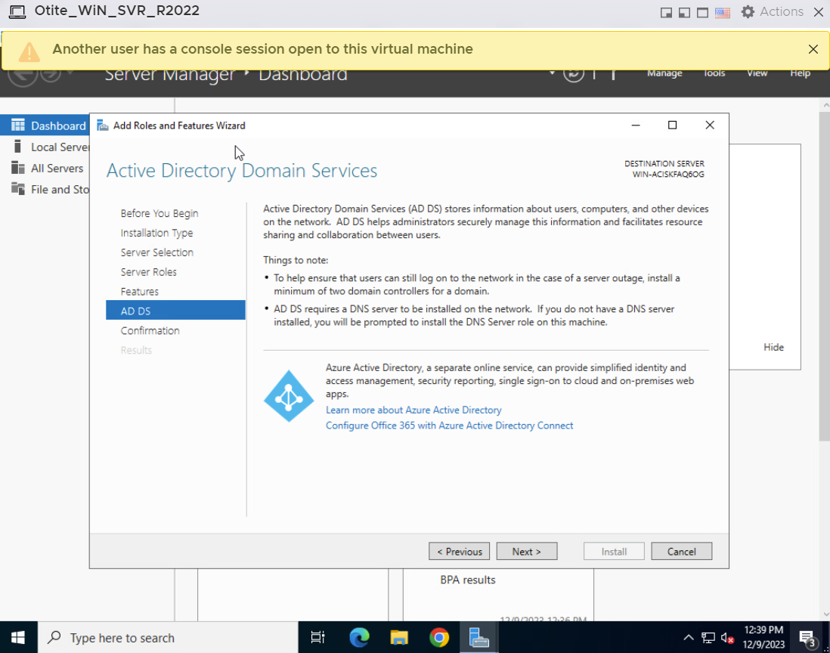

1. The system will show you a summary of you selections (You can still go back to make changes if you made a mistake):

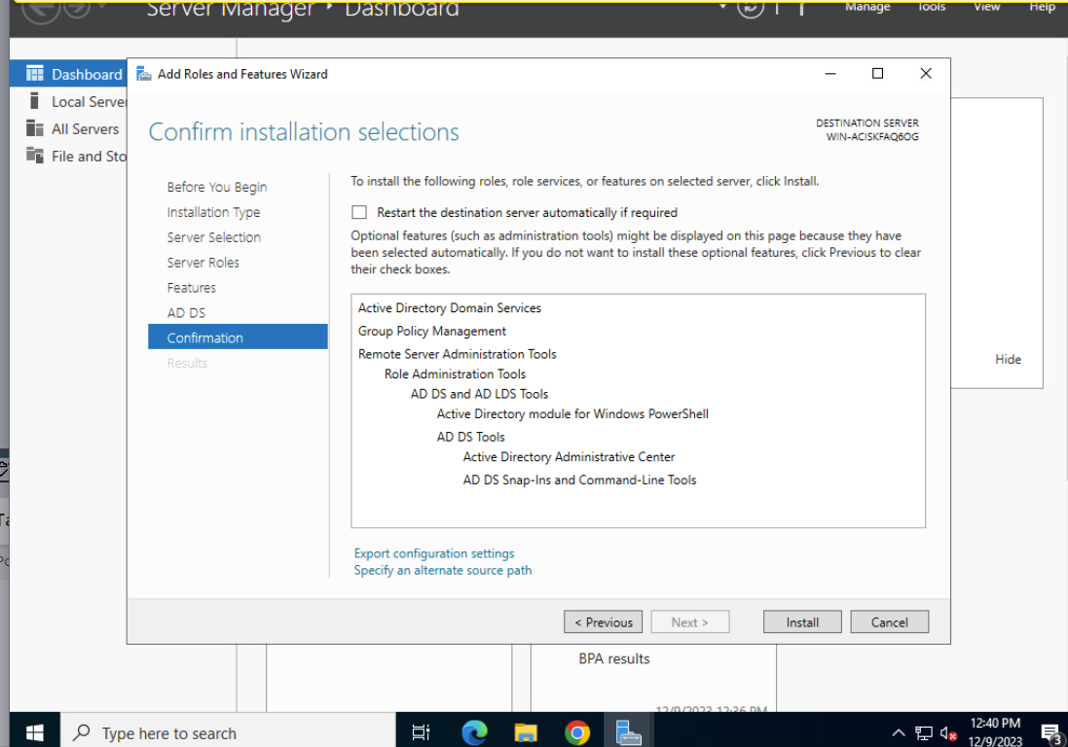

1. Next select “Installation process begins”:

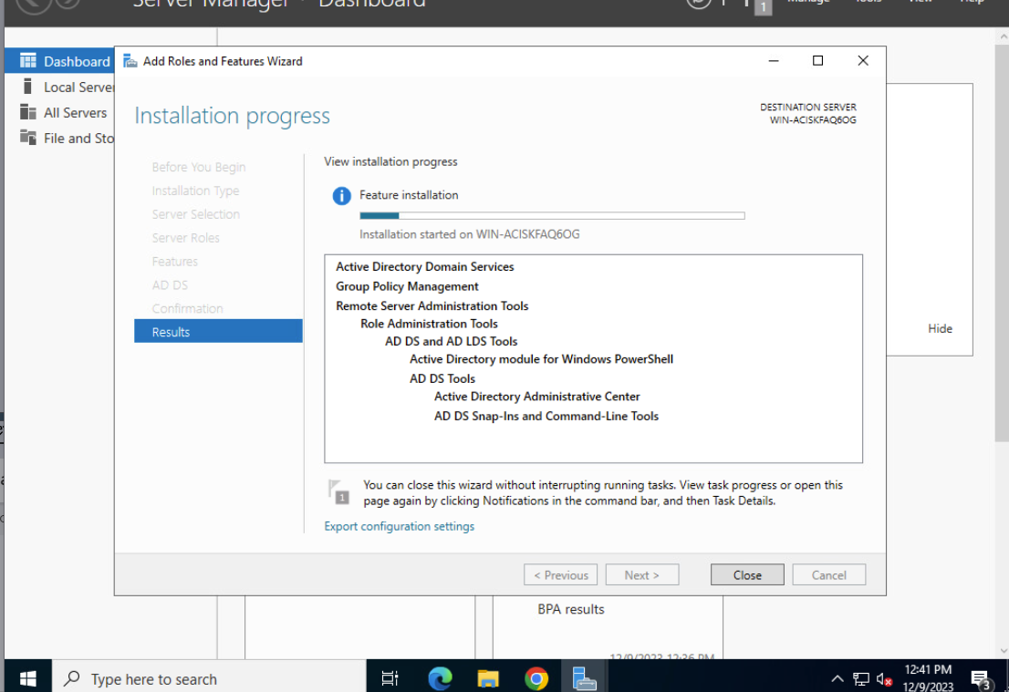

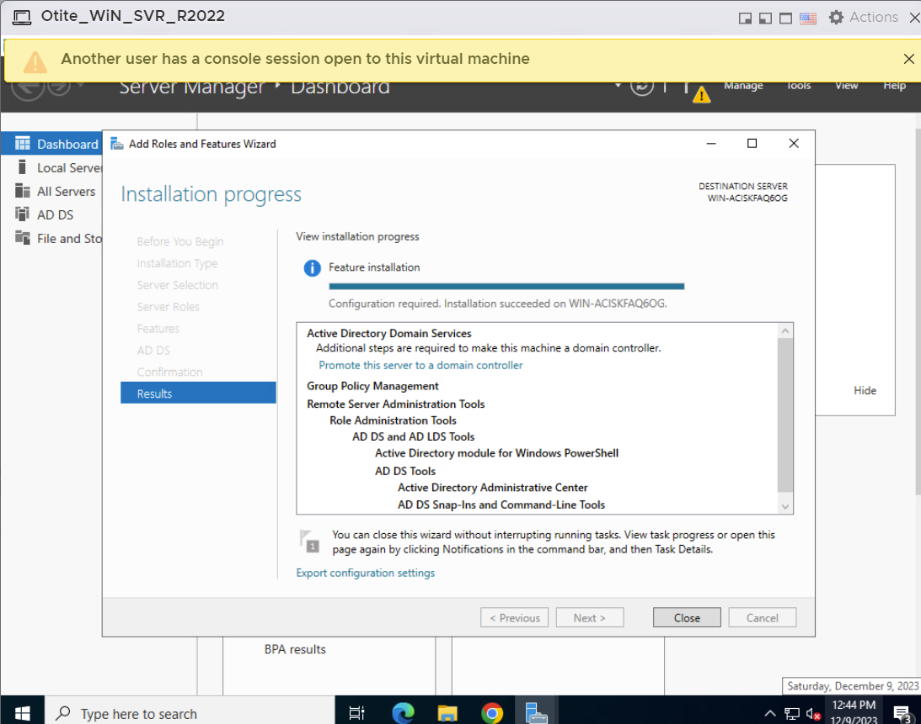

1. We now need a controller:

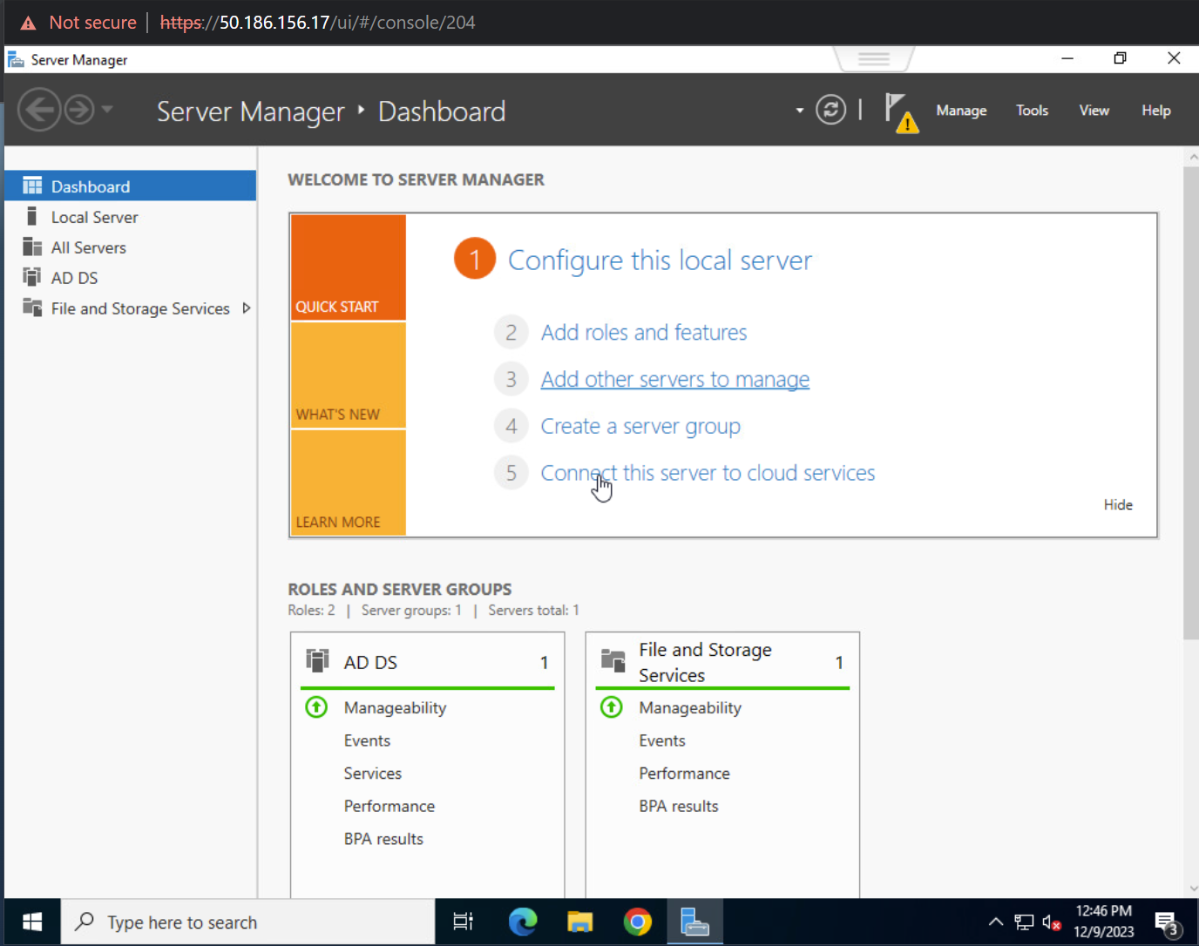

1. Click on the warning sign icon on the tool bar:

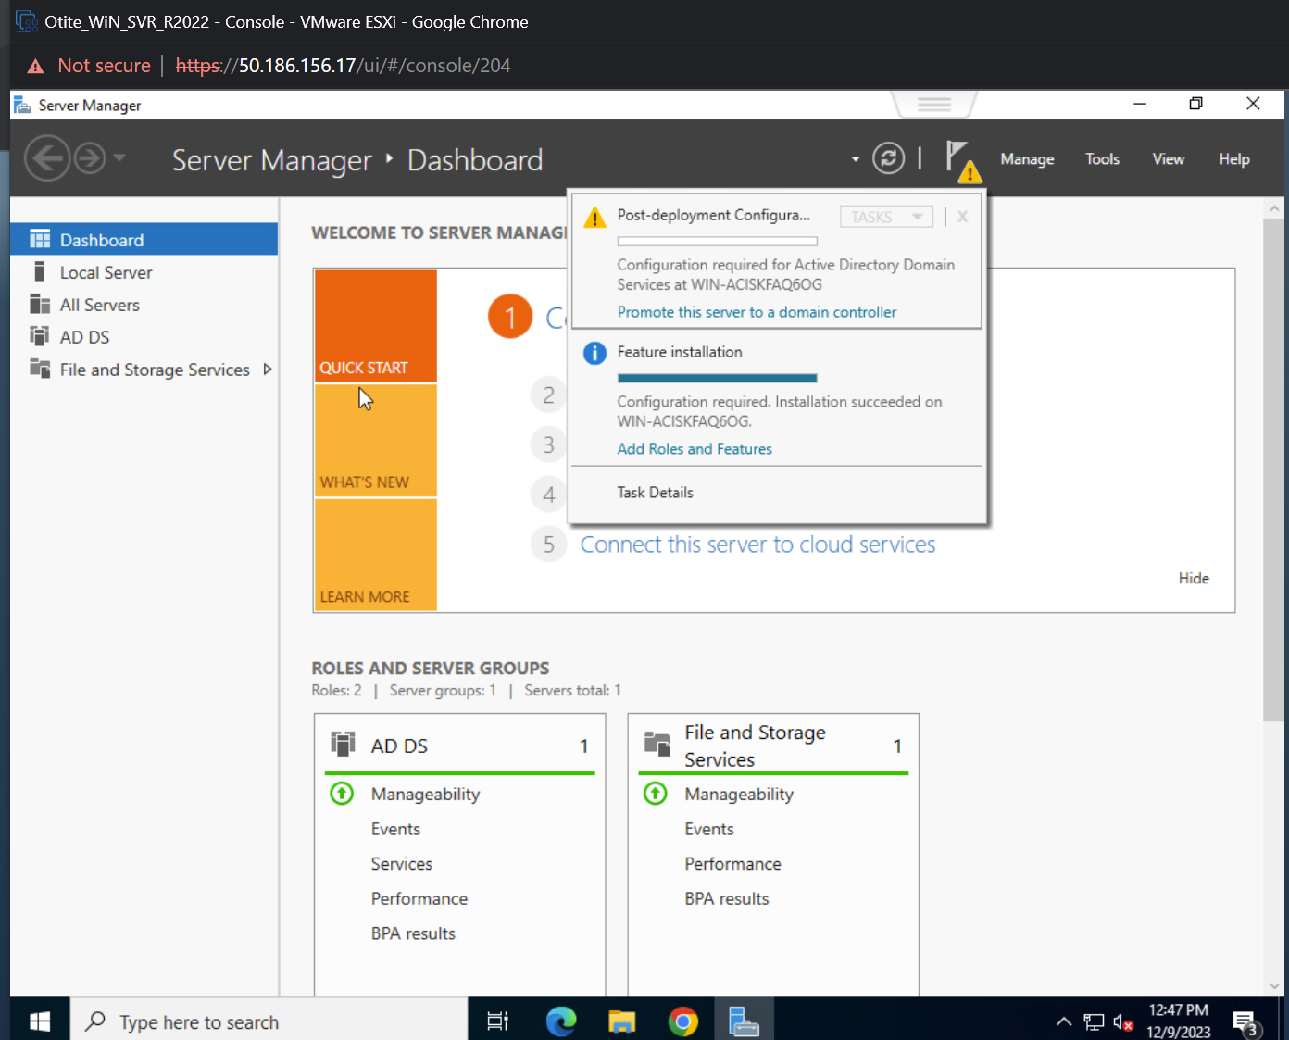

1. Based on the requirement select the deployment operation:

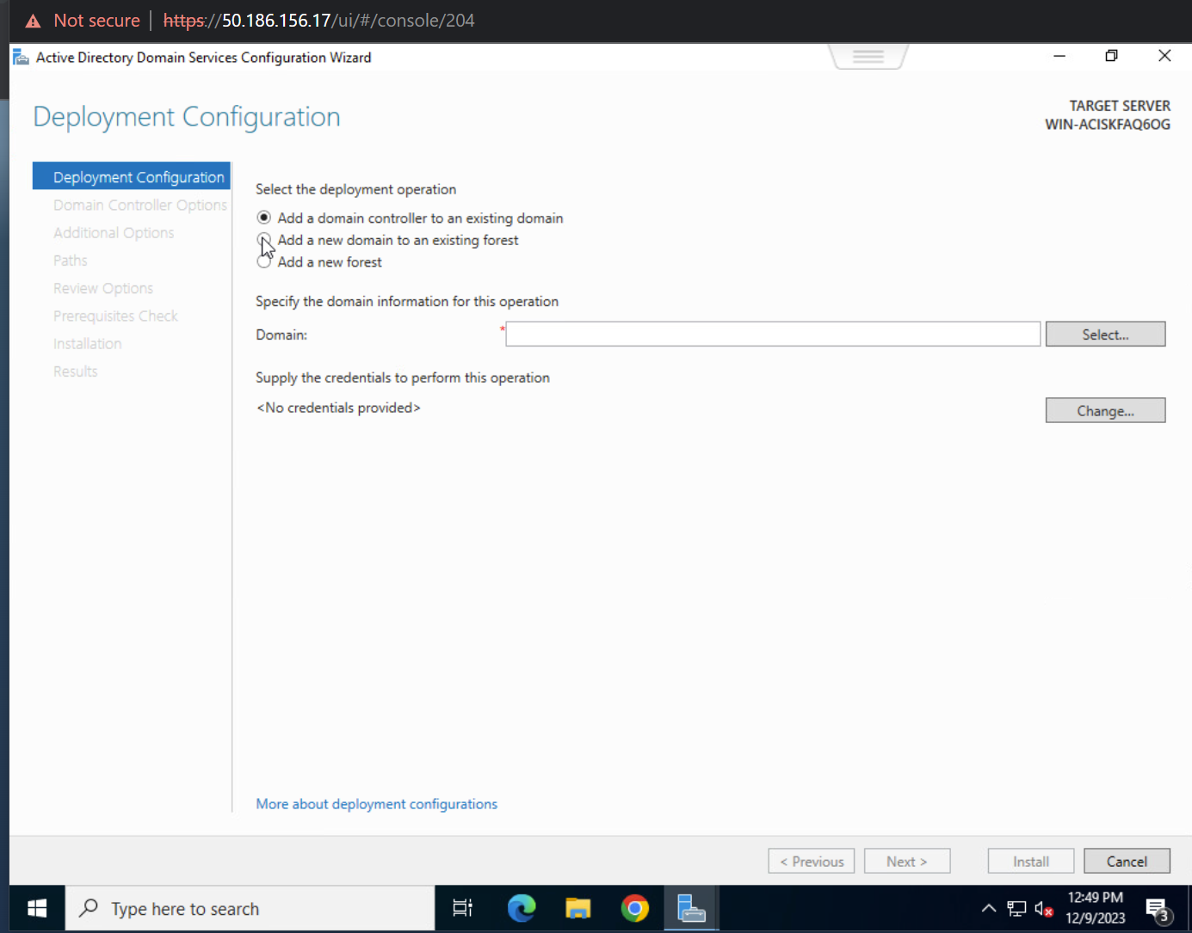

1. Adding a new forest:

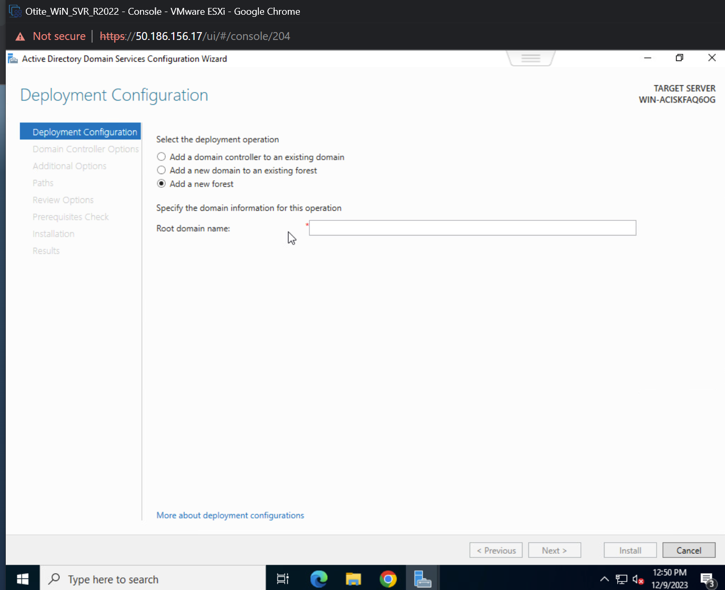

1. Follow the naming conventions: (otite.git-gotech.pro):

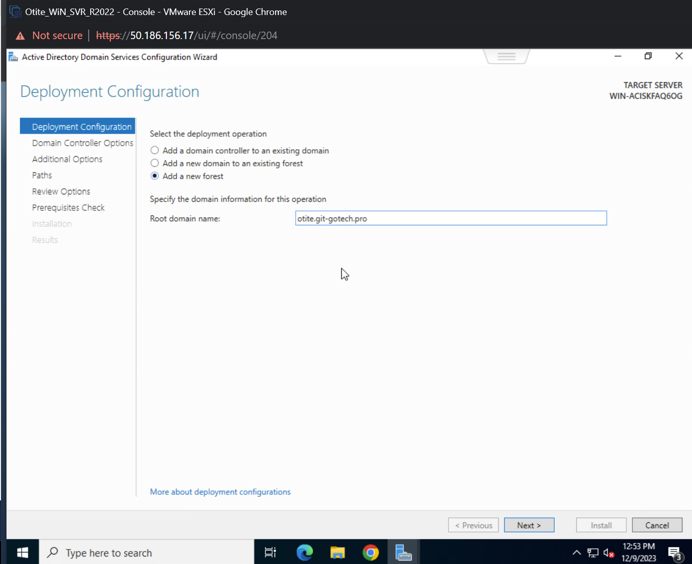

1. Enter your password and confirm the password:

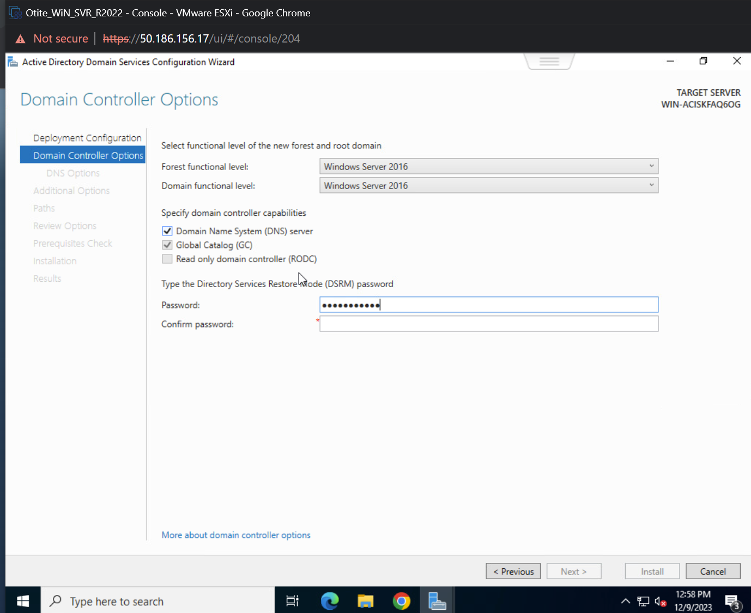

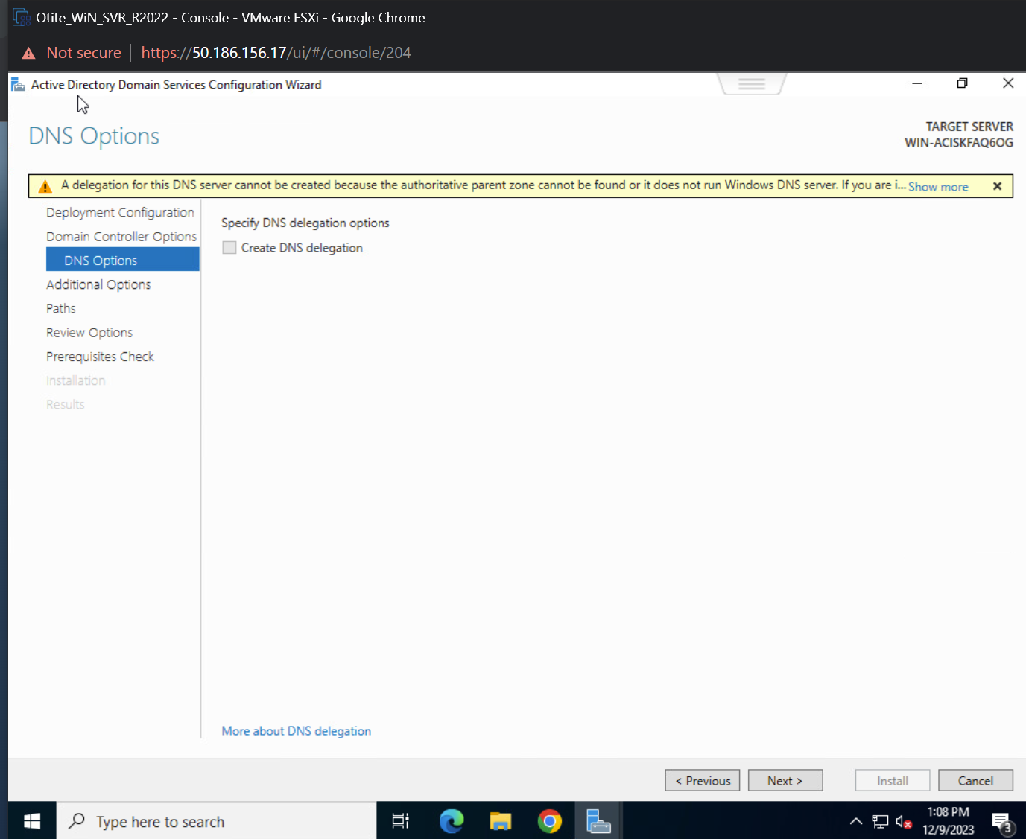

1. We do not need the DNS Options:



1. Under additional options (Verify the name is “OTITE”):

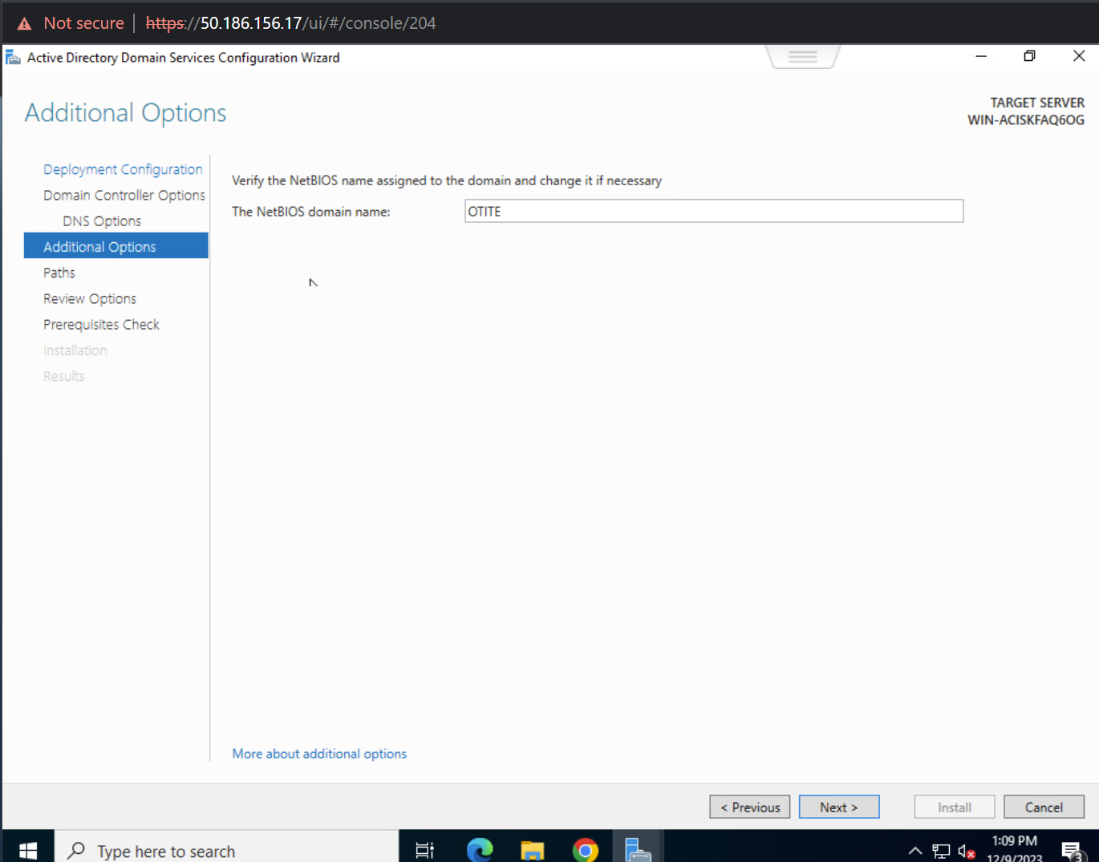

1. Based on your Partitions select your backup partition (By clicking on the 3 dots to the right):

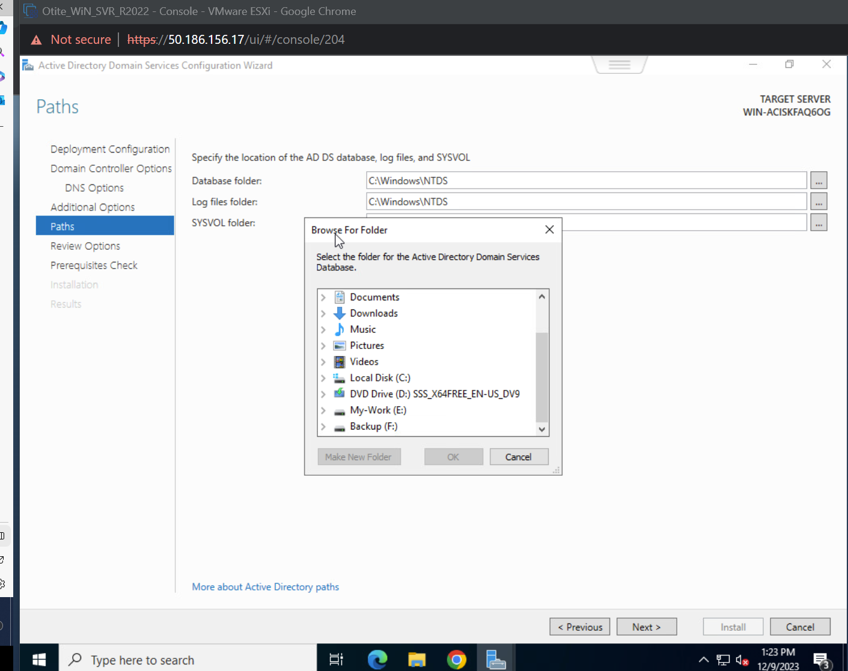

1. After you select your other drive, create another level folder (F: Drive):

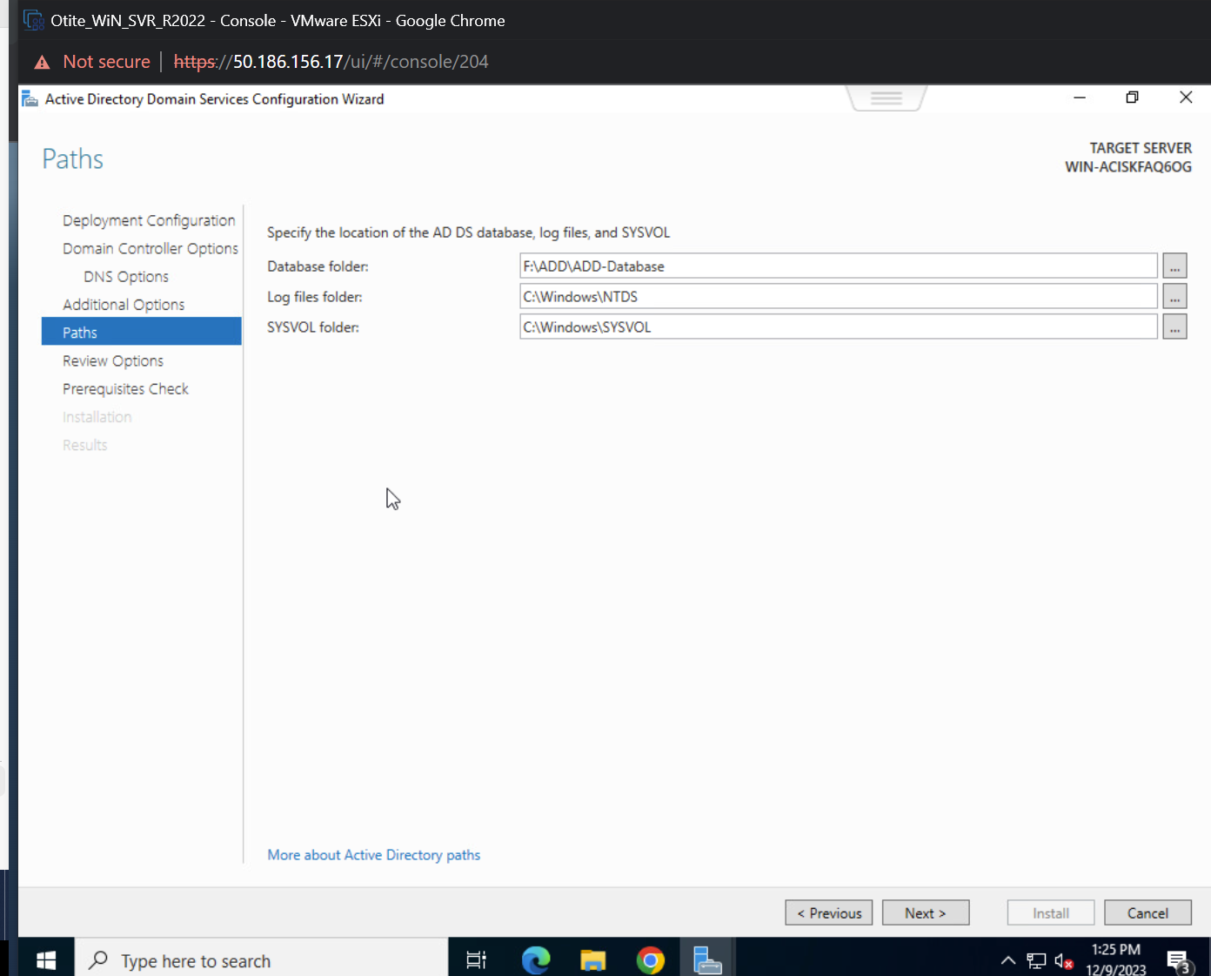

1. I did the same for the next 2 levels (Logs and Sysvol):

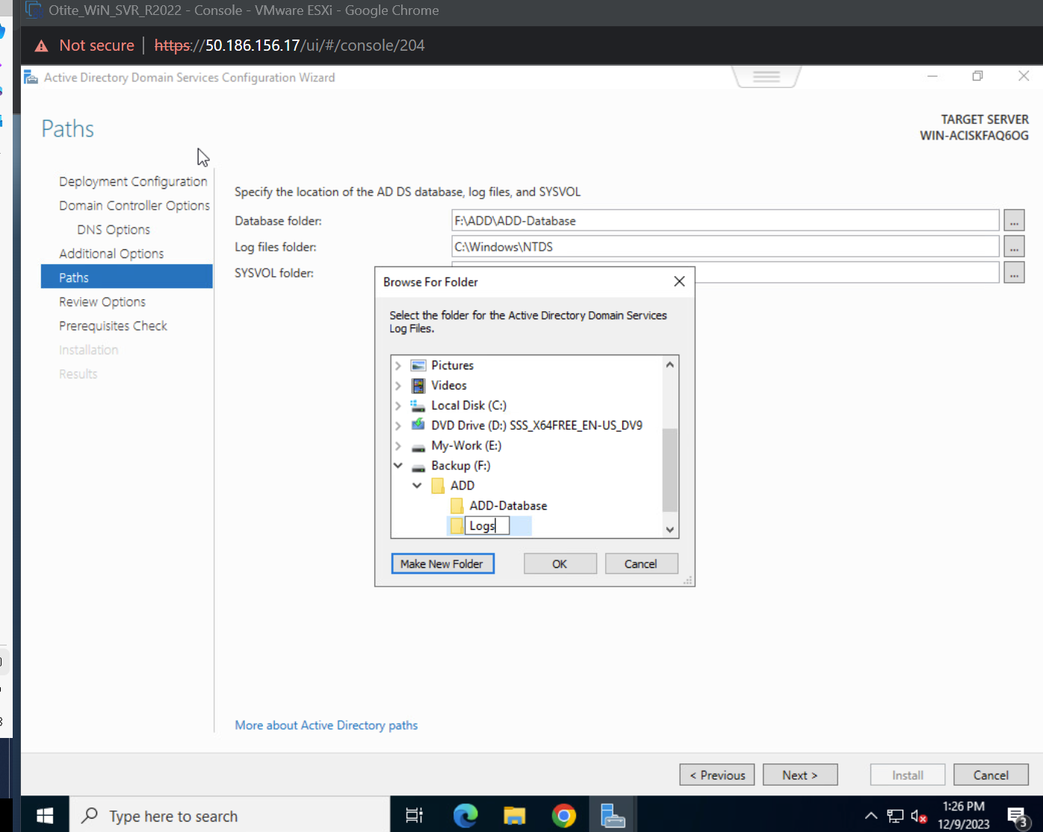

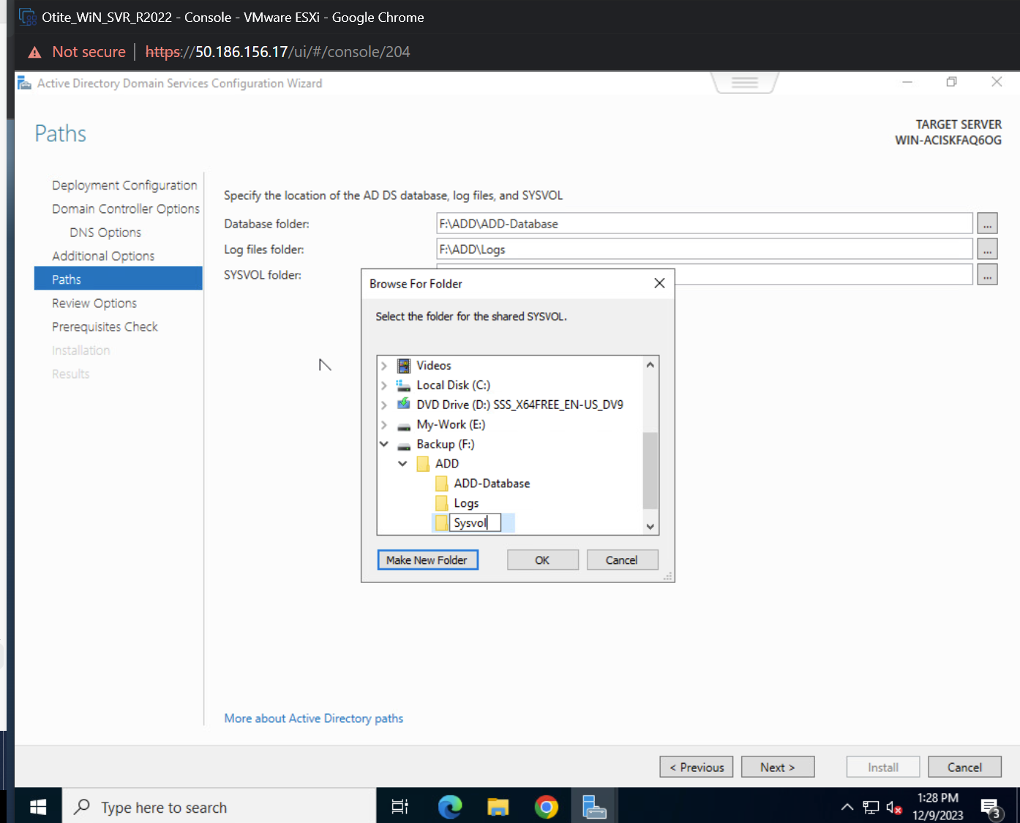

1. This would conclude the Paths:

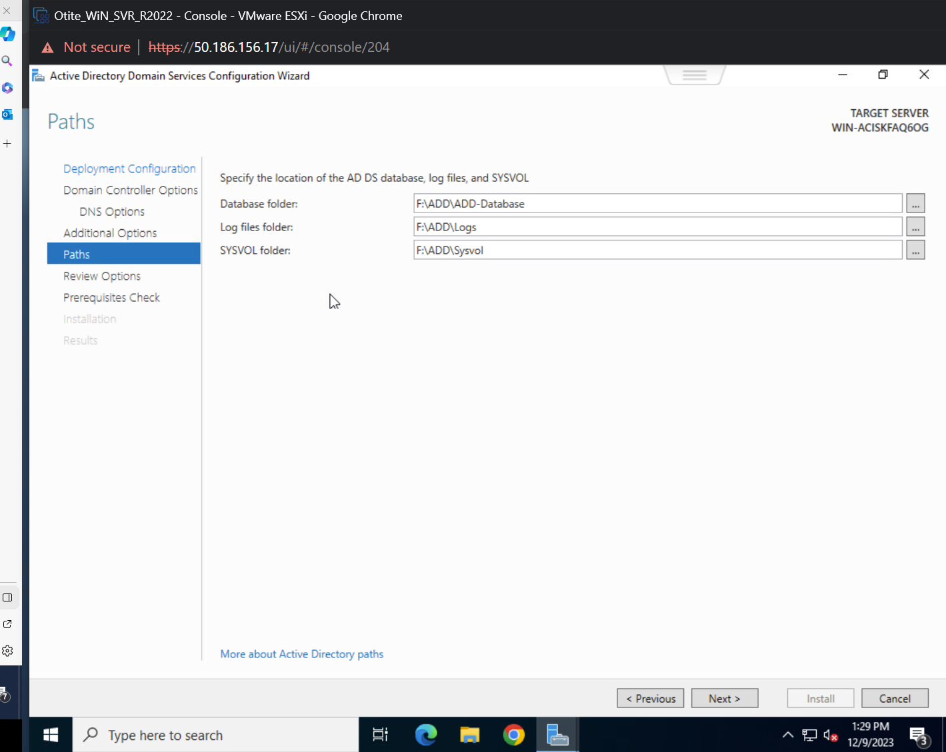

1. A summary of everything will be displayed below. Followed by a Prerequisite system check:

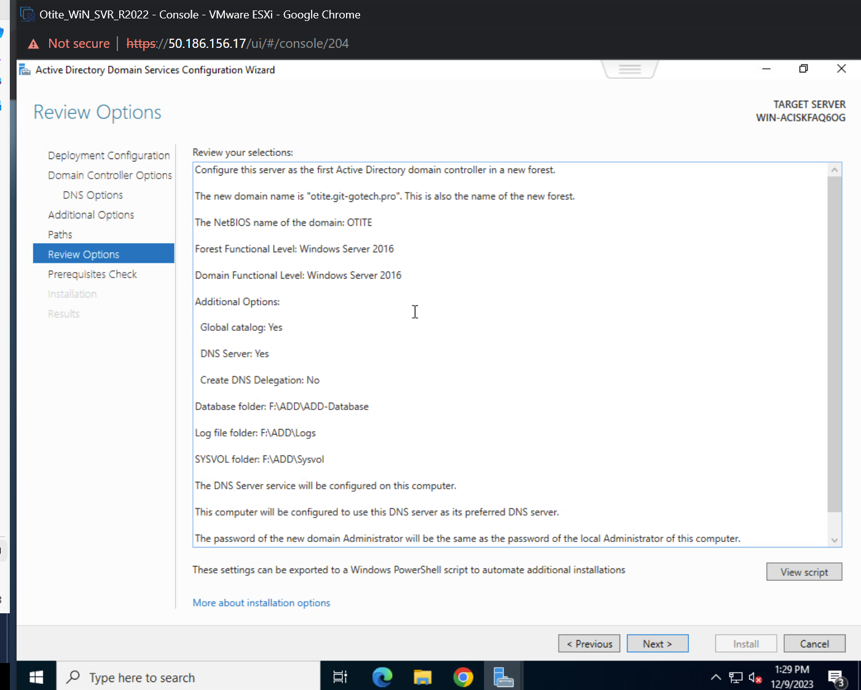

1. PowerShell script (Show a script option if we did this in the command screen):

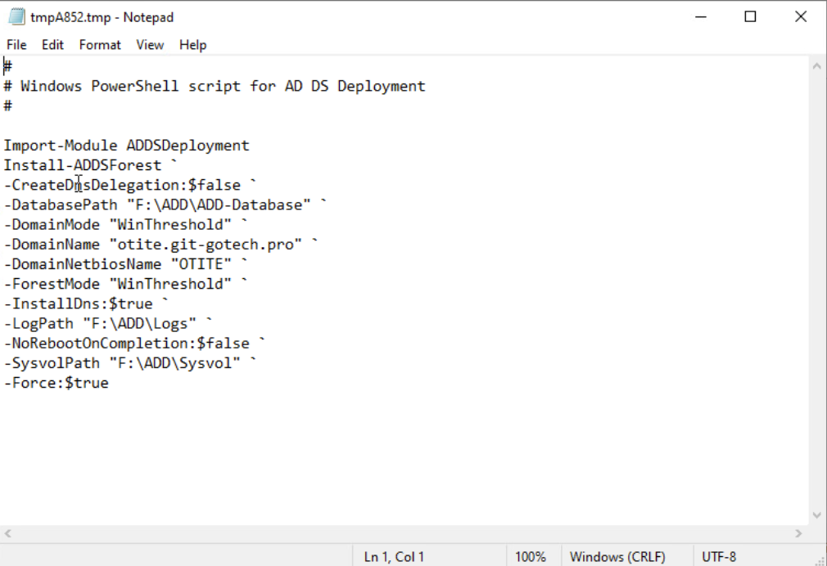

1. The system will run a check:

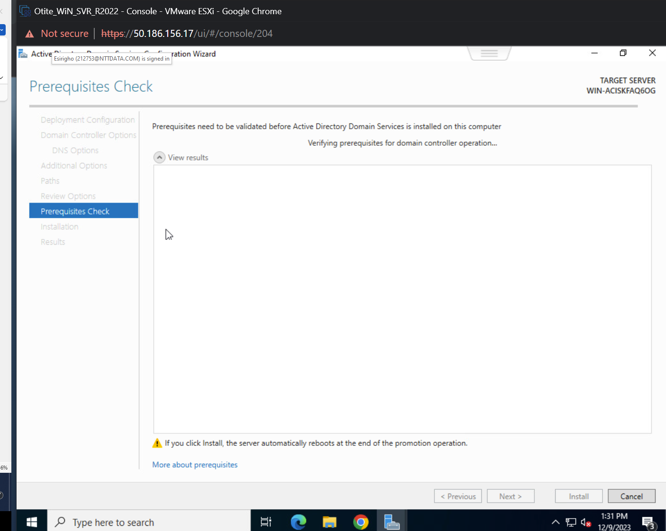

1. System Passed. Now Install:

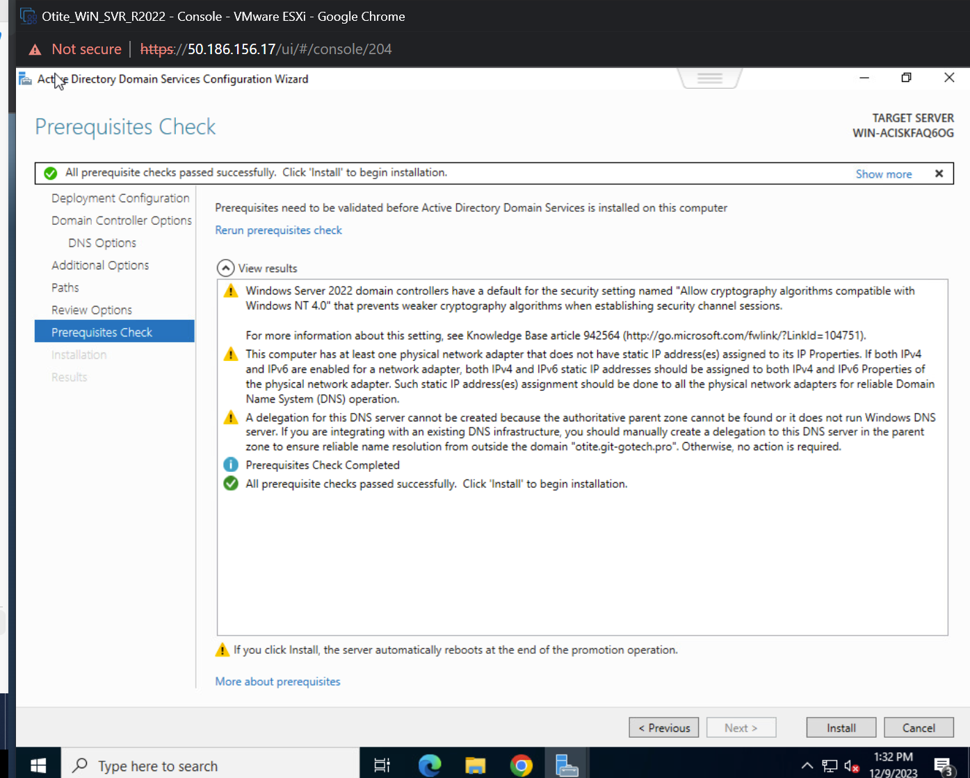

1. The system will auto reboot:

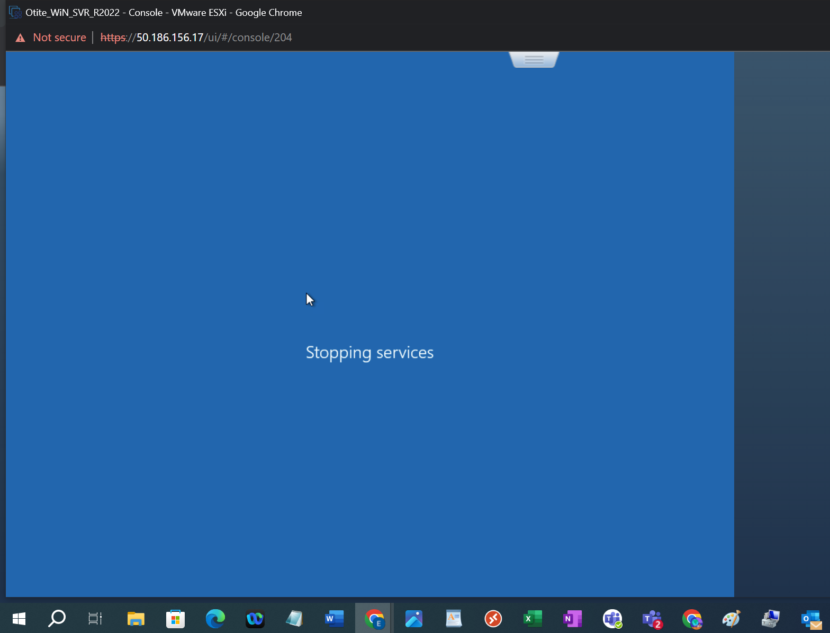

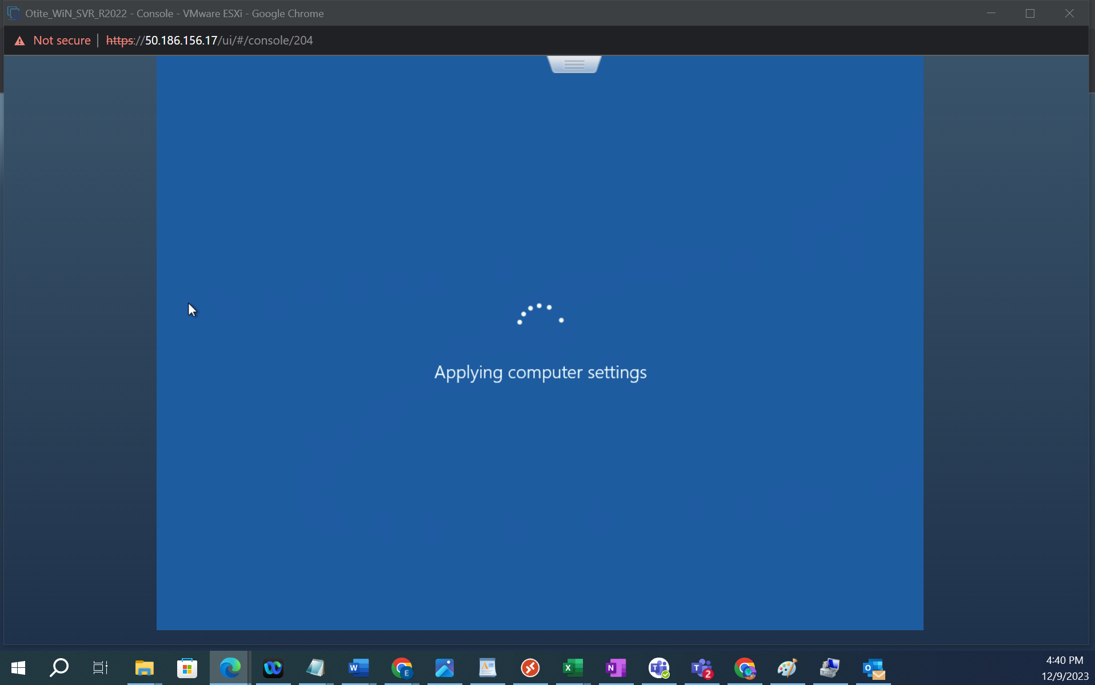

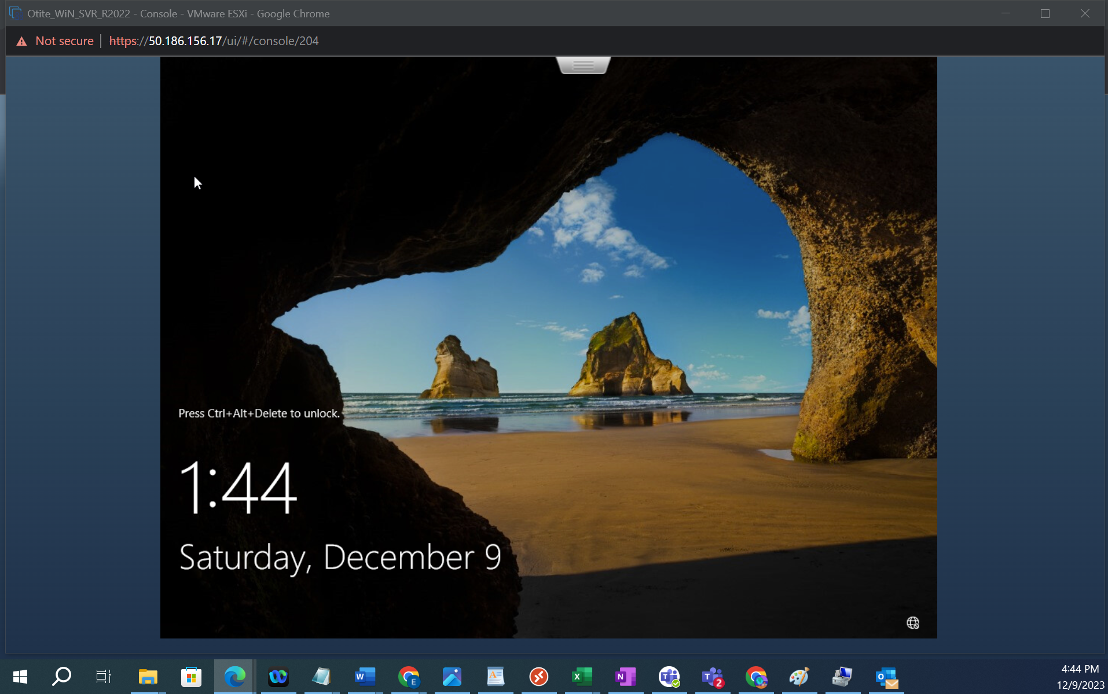

1. Now you can login. Notice it shows a domain name “otite”:

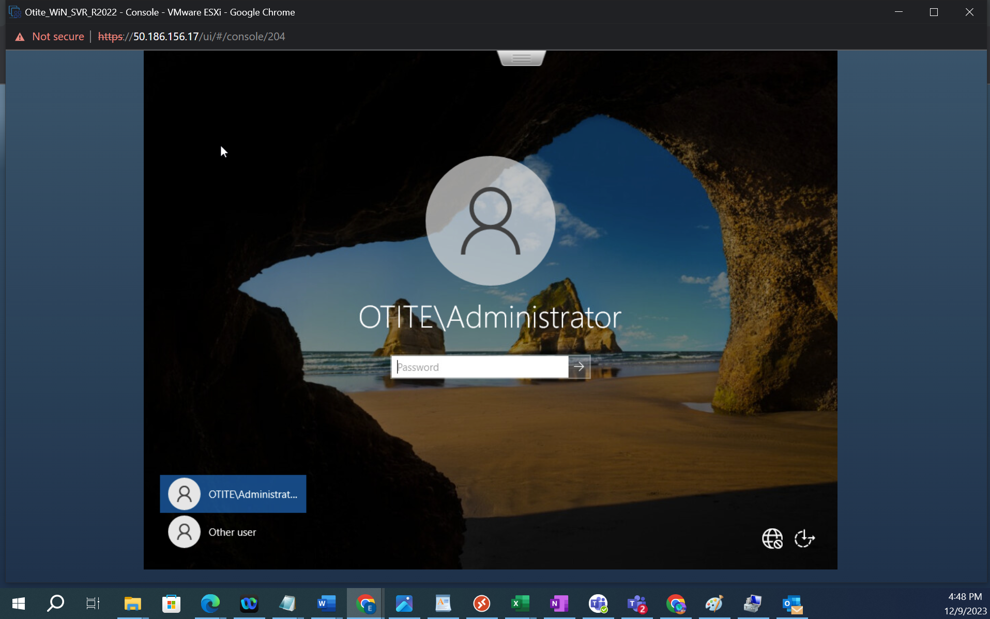

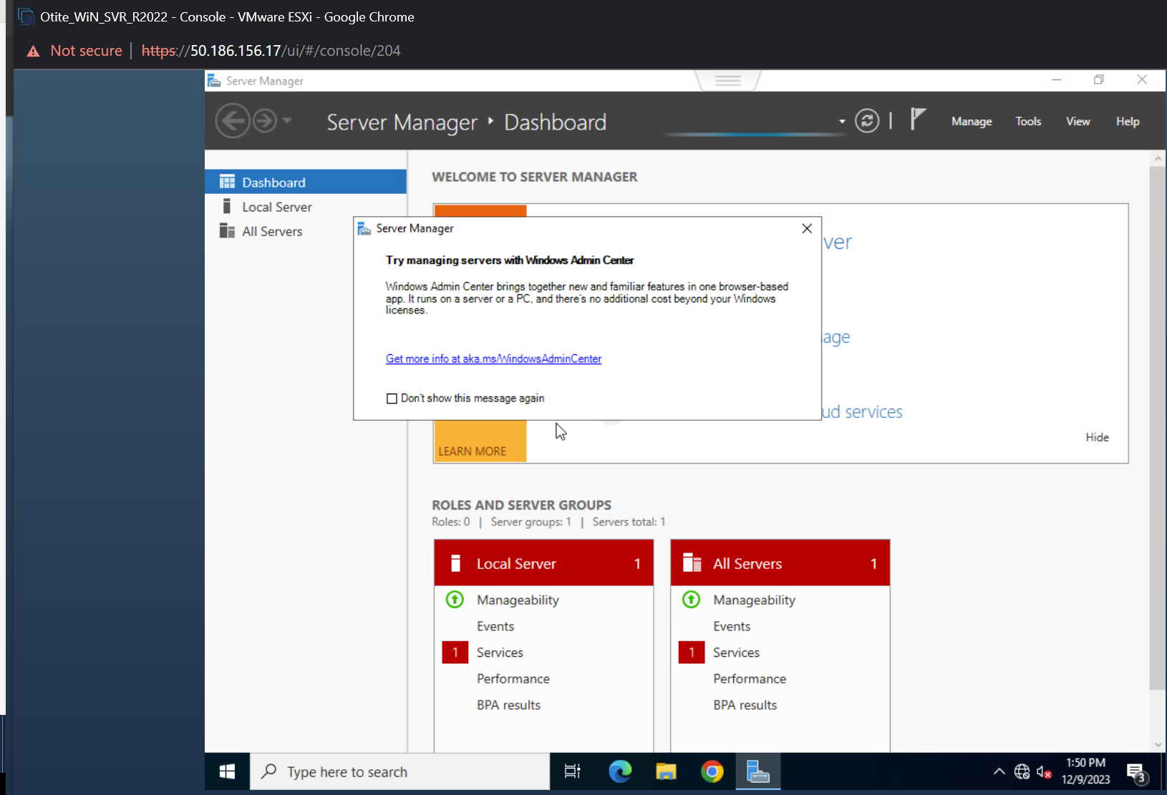

1. This is exactly my apps and desktop setup in the vmware:

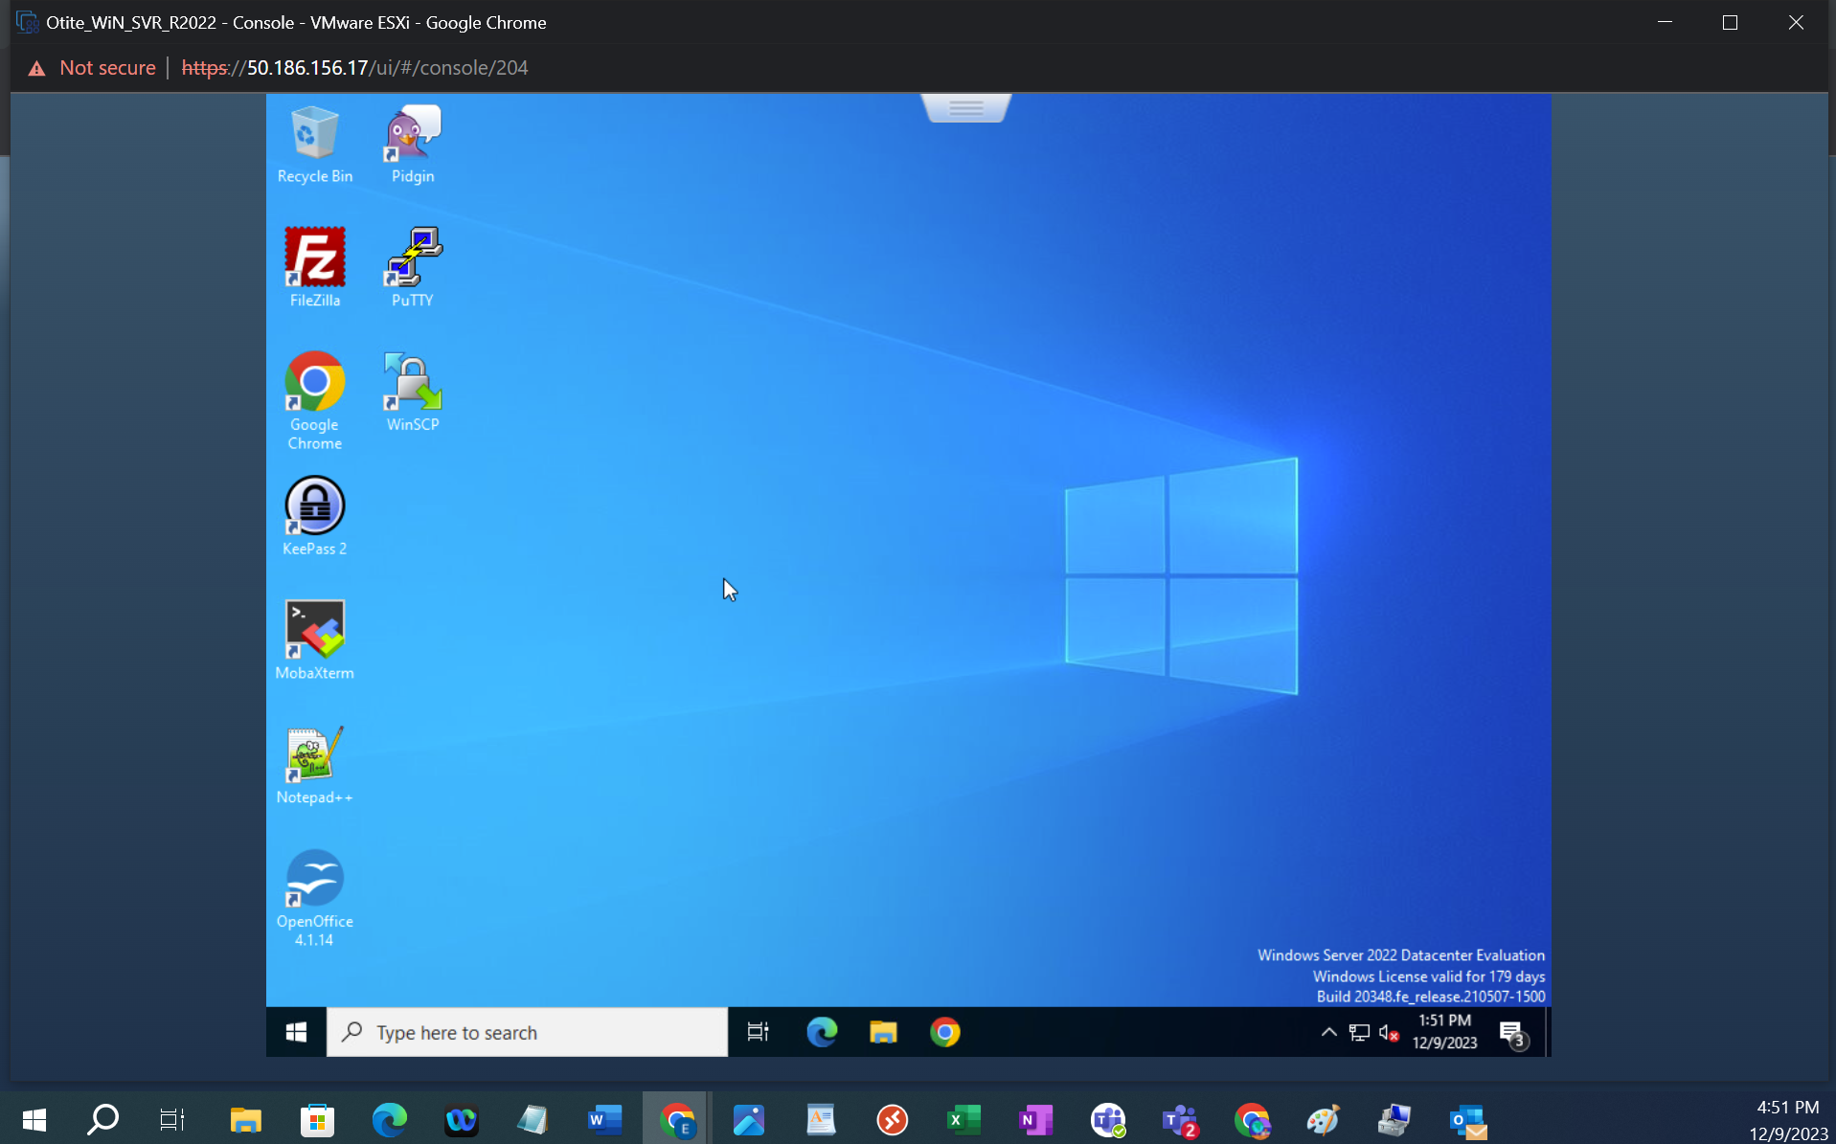

1. Active Directory steps completed successfully. 😊